Life Cycle Impact Assessment Report of Ice Bag Sleeve Methods

1. Classification and Characterizations

There are many different ways that a project can negatively affect the environment. Currently, the athletic ice bag process uses 300lbs of single-use plastic per year, negatively affects the environment by destroying habitats, depleting nonrenewable resources, and producing CO2 that contributes to global warming. By switching to the new method of producing and attaching athletic ice bags we eliminate most of the habitation destruction impact that the current ice bags are causing and reduce the amount of CO2 produced because of the ice bags. Citations for the variable data of the following calculations are located within the calculations.

Method | Global Warming | Habitation destruction | Depleting nonrenewable resources
Plastic Ice Bag Wrap | yes | yes | yes
Fabric Ice bag Wrap | yes | n/a | n/a
Table 1: Environmental classification risk matrix for the two types of ice bag wraps.

2. Valuation For Production

At Elizabethtown college the amount of plastic saved each year by this project will be around 90% of the plastic wrap used by the athletic department, this is estimated to be roughly 300 pounds of plastic a year. Polyethylene plastic takes 4.5 x 10^7 J/kg to produce. Using this production energy rate it can be calculated that eliminating 300lbs of plastic will eliminate the need for 6123 MJ of energy a year.
Though this reduction of plastic wrap is exciting, the amount of fabric and velcro use increase should not be forgotten. Production of one kilogram of polyester fabric takes 125 MJ of energy. Using a fabric density of 0.98 g/cm^3 and the large ice bag sleeve dimensions, the energy needed to produce the fabric for one ice bag sleeve can be found. For one large sleeve, it takes 4.817 MJ to produce. In the manufacturing of velcro, it uses polyester like the fabric used in the ice bag sleeve, so the carbon production caused by manufacturing velcro is very similar to manufacturing polyester. Since there are four large strips of velcro per a large ice bag sleeve, the needed velcro produces 2.328725 MJ per a large ice bag. By adding the energy needed to produce both the fabric and plastic wrap together the total energy needed to produce one large ice bag is 7.146285 MJ. To produce the fabric for a full stock of forty-five ice bag sleeves it will take 321.582825 MJ, which is still substantially smaller than the energy it takes to produce the 300 pounds of plastic.
Ideally, the fabric ice bags will last for a few years, though in order to factor in fabric ice bags getting lost and to keep the calculations liberal it will be assumed that the full stock of fabric ice bags will be replaced one a year. The amount of fabric used per fabric ice bag wrap is 32.12 grams, while the velcro used is 6.45 grams. This makes the total weight of one fabric ice bag wrap 38.57. A full stock of 45 ice bag wraps will take up 3.825lbs. In comparison 3.825lbs of fabric and velcro waste is minuscule to 300 pounds of plastic that would have been thrown out using the plastic ice bag wrap.

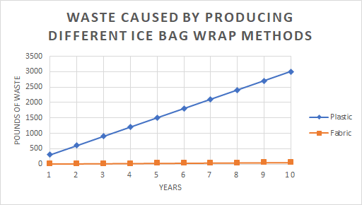
Figure 1: Chart showing the amount of waste produced throughout the years by the different ice bag wrap methods.

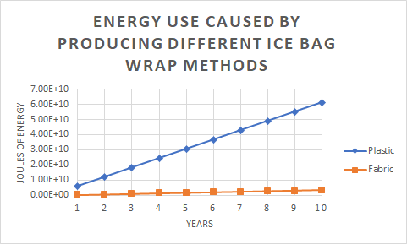
Figure 2: Chart showing the amount of energy used to produce materials throughout the years by the different ice bag wrap methods.

3. Validation After Production

After the production of the fabric ice bags there are two more factors that need to be considered in this method of ice bag wrapping; replacing lost wraps and the energy needed to wash the ice bag wraps. For the plastic ice bag wrap, there is no more energy consumption to that method after production.
Another factor that needs to be reflected in the energy calculation for the fabric ice bag wrap is that it will need to be washed regularly since that wrap will be placed on an athlete directly after they finish their workout, causing the fabric ice bag wrap to smell like body odor. To avoid this odor it is recommended to wash the fabric ice bag wrap after every use, especially when sharing the same fabric ice bag wrap with multiple people. Preferably, the fabric ice bag wraps will be air-dried but it can also be put in a dryer. Because of the calculations for electricity consumed by the fabric ice bag wrap is liberal, the energy consumed by the dryer for the ice bag wraps will also be added to the final energy calculation for the fabric ice bag wraps. The fabric ice bag wrap is small and will not need its own load of laundry, resulting in only a small portion of the energy used to run the laundry machine and the drying machine will be contributed to the fabric ice bag wrap calculation. A typical laundry machine can wash 7-8 pounds of clothing per load, this means that since an ice bag weighs 0.085lbs, it takes up 0.012 of the laundry machines capacitance. Since the same amount of laundry that goes through a laundry machine also goes through the dryer, the same laud capacitance ratio will be used on the laundry machine as the dryer machine. Because a maximum of twenty fabric ice bag wraps is used daily this means a total of 140 fabric ice bags will be washed per week. This makes up 1.7 loads of laundry in total per week. Since the athletic department rarely uses ice bags for four months out of the year it is converted to three months of not washing the fabric ice bag wraps. This helps make the total loads of laundry for the fabric ice bag wrap be 65.03 loads a year. This amount of laundry loads calculates to 11.7 MJ per year spent on washing and drying fabric ice bag wraps. So in total, it will take 333.28 MJ per year to produce and maintain a full stock of fabric ice bag wraps.

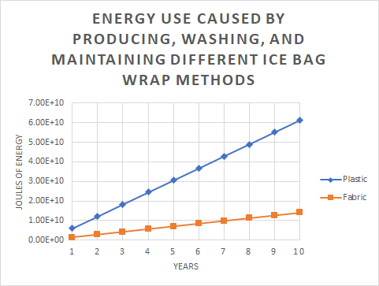
Figure 3: Chart showing the amount of energy used to produce and maintain materials throughout the years by the different ice bag wrap methods.

4. Conclusion

As seen in figure1 and figure 3, by switching from the plastic ice bag wrap to the fabric ice bag wrap a large amount of waste will never reach landfills and a large amount of energy use will be avoided. Every year 296lbs of single-use plastic could avoid use and 5789.72 MJ of energy could be saved. These reductions of both waste and energy use are substantial. Energy use from material production will be reduced by 82%, while waste will be reduced by 98%. Citations for the variable data of the calculations will be found within the calculations.

